**Suggested Reading:** Bunker (Chapter 3.3 and 3.4) [1]

**Vocabulary Words:**

**Brightness:** The number of photons emitted per second, per square millimeter of source size, per square milliradian of opening angle, within a given spectral bandwidth. Is used as a measure of the concentration of the radiation.

**XFEL:** X-ray Free Electron Laser (XFEL). A synchrotron which produces very short brilliant pulses of x-ray radiation through a stimulated emission process that relies on relativistic electrons.

**Coherence:** A measurement of the alignment of the phases of the electric field vectors of the radiation emitted by the synchrotron

**Exercise:**  Below is a diagram of a synchrotron. Using the words in the box, fill in the blanks and label each component of the synchrotron.

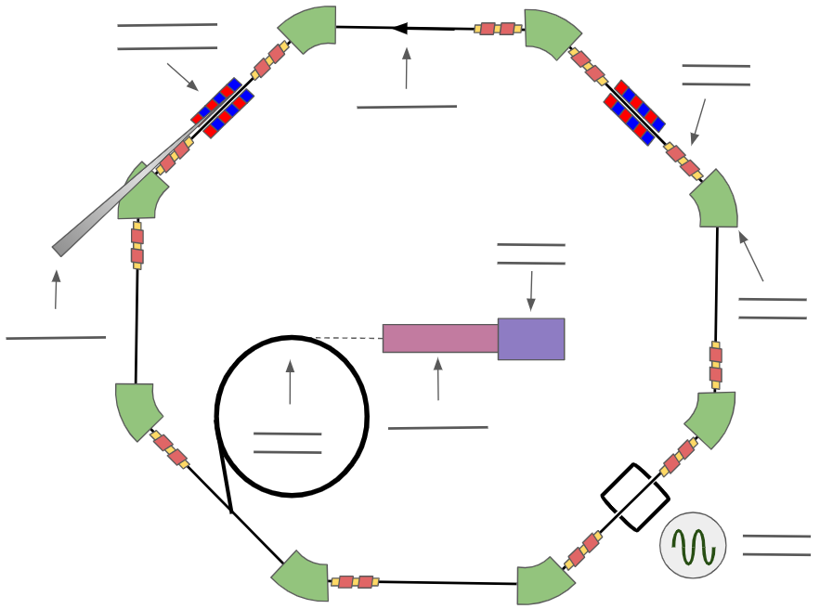

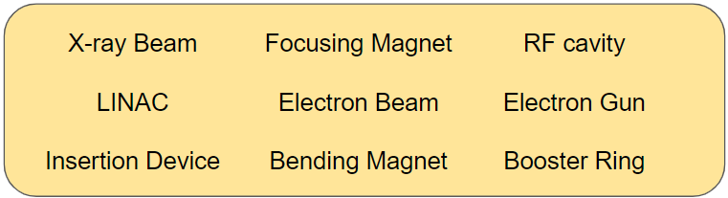

1. Magnetics
2. Within a synchrotron, bend magnets are responsible for curving the electron beam as it travels, allowing it to be contained in a storage ring. Why is it necessary to have some sort of focusing magnets between each of these bending magnets?

Every time the beam is bent it will spread out due to the fact that all realistic beams have some non-negligible energy spread. When they pass through a bending magnet, Lorentz’s equation dictates that electrons with different velocities will experience different forces, meaning that each electron will be “bent” by a different amount. The focusing magnets are in place after each bending section to counteract this effect.

1. When electrons move through the bending magnets they are moving at relativistic speeds, and emit significant amounts of radiation. Draw two pictures of the radiation coming off an electron: one from the electron’s reference frame and one from the laboratory reference frame.

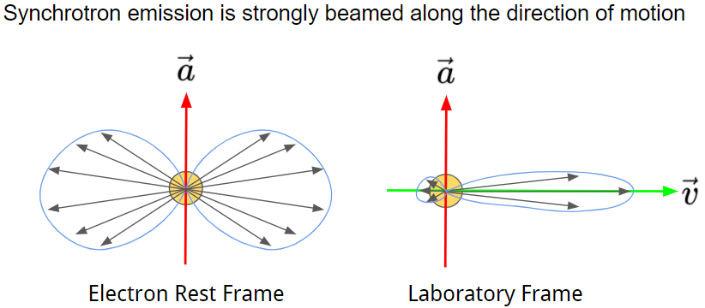

1. Dipole bending magnets are useful for keeping the beam traveling in a loop and creating the radiation needed to perform the XAS measurements. However, insertion devices (see diagram in problem D) are also used in between bending magnets to create additional radiation. Explain (generally) the main benefits these devices provide over bending magnets in terms of radiation flux.

Insertion devices consist of alternating magnets which cause the electron beam to “wiggle”, which gives off additional bremsstrahlung radiation. One main advantage is that many of these alternating magnets can be placed in succession, effectively creating the radiation of multiple bending magnets with each alternating magnet in the insertion device. Another main advantage is the reduction in emission angle (for undulators) compared to a compared bending magnet, which increases the flux density. Finally, they are tunable in some cases. The period between the magnets can be manipulated allowing the x-ray radiation to also be tuned.

1. Below is a picture of one of these insertion devices. Sketch the behavior of an electron beam travelling through it and the radiation it emits as it passes through the device (from the laboratory frame). When drawing the radiation, remember to consider the points at which the electrons are experiencing the strongest acceleration.

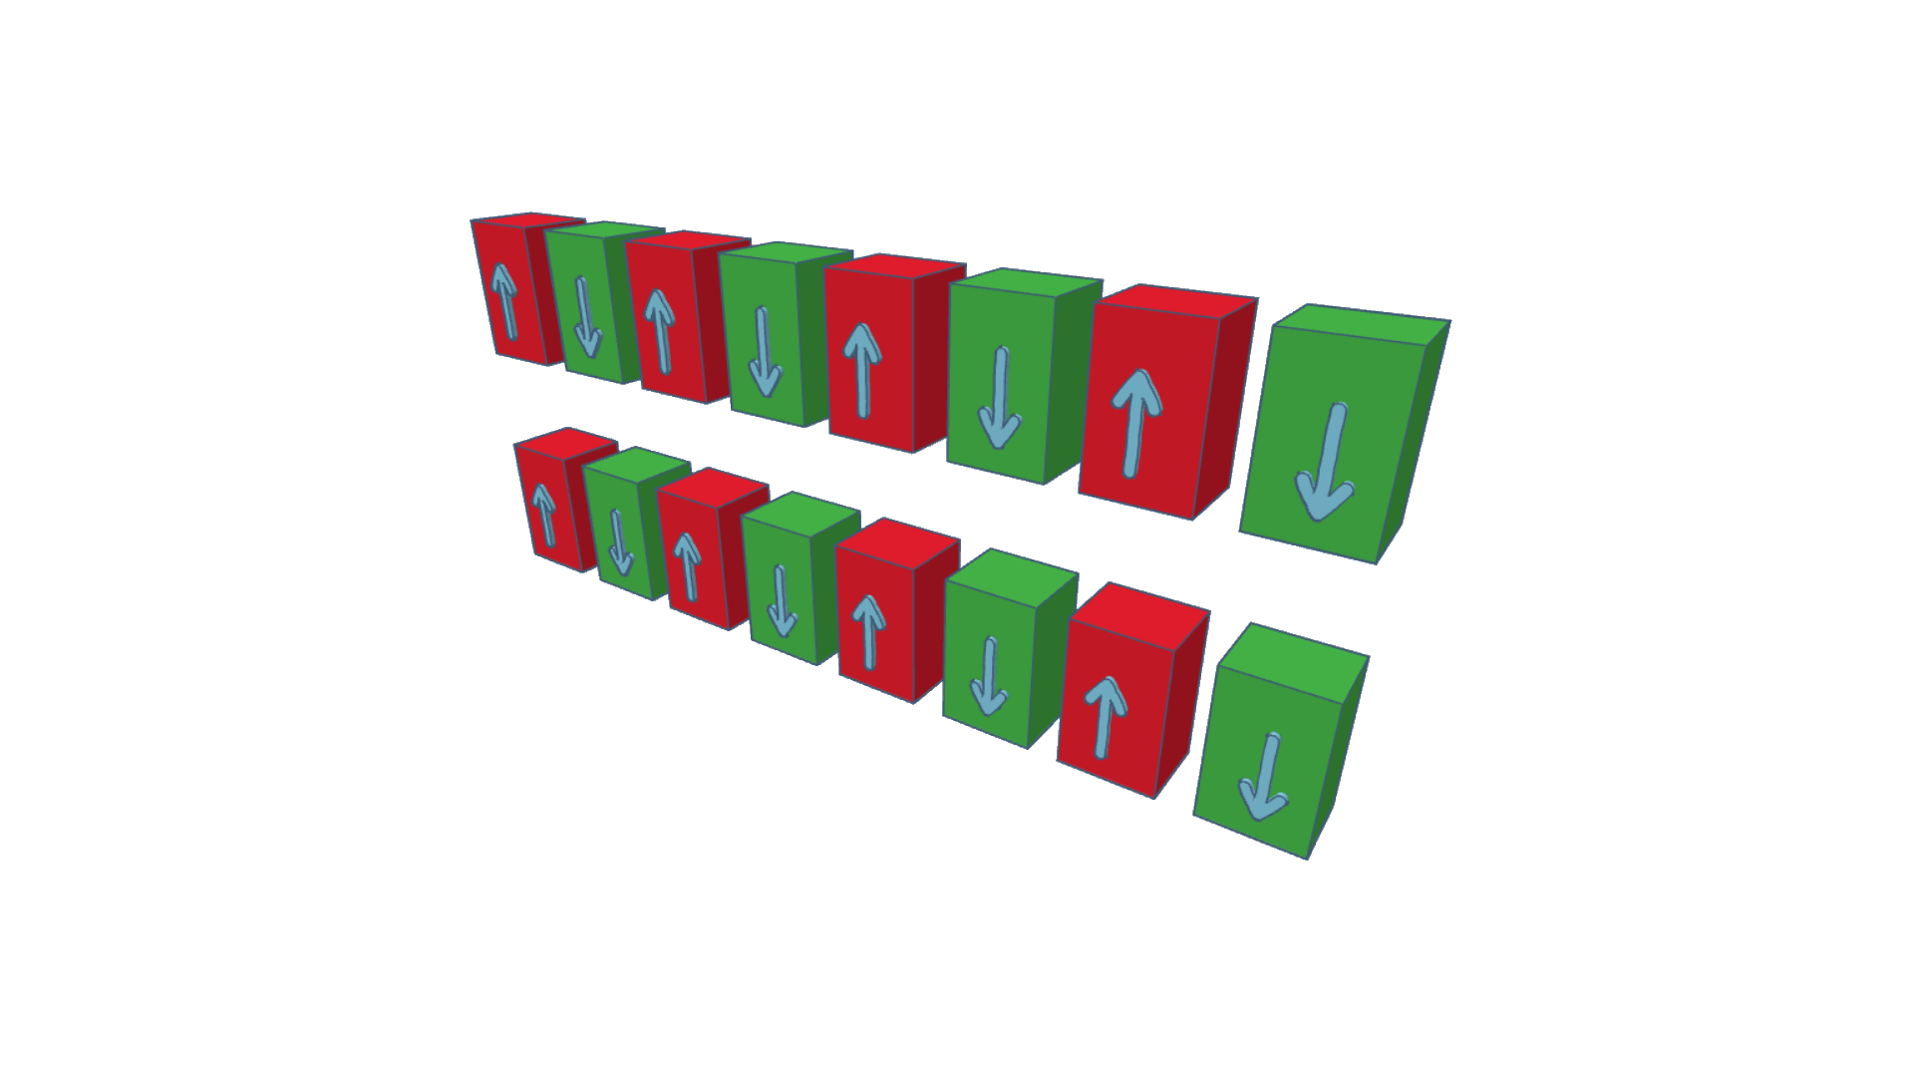

The electron beam will oscillate back and forth as it passes through the undulator, much like a sine wave. At the peaks of the wave where the acceleration is greatest, a cone of radiation will be emitted, in the direction the beam is traveling.

1. Insertion devices usually come in two forms: “undulators” or “wigglers”. One common method of defining them is by the strength (sometimes called deflection) parameter K, where $m_{e}$ is the electron mass, $e$ is the electron charge, $c$ is the speed of light, $B$ is the magnetic field, and $λ_{u}$ is the spatial period of the magnets.

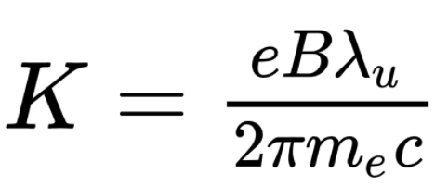

Insertion devices are generally considered to be undulators in the $K≪1$ limit, and wigglers in the $K≫1$ limit (while $K$ is a sufficient benchmark, the cutoff between undulators and wigglers also depends on the energy range of the radiation that we are interested in, so the distinction is not always black and white). In their respective limits, what is the key difference in between wigglers and undulators in terms of the radiation that they produce?

Undulators produce large spikes of radiation at particular energies (harmonics). This radiation is usually more (but not entirely) collimated. Wigglers are closer to bend magnets in the large K limit, and their radiation covers a broad spectral range. However, they produce a much larger radiation flux compared to bend magnets. Finally, while neither of them produce entirely coherent radiation, the radiation from undulators is generally “more coherent” than wigglers.

1. Briefly describe how undulators are used in a device like a free electron laser. What is the difference between the design of an undulator used in a free electron laser and an undulator used in a synchrotron? What is it about this undulator design that is fundamental to the operation of a free electron laser?

A free electron laser effectively uses a massive undulator, on the order of 100 meters long. This is key as it allows for self-amplified spontaneous emission (SASE), creating a quasi-coherent beam of radiation. The electrons in an undulator are moving close to the speed of light, and they emit photons (at the speed of light) along their direction of motion. These photons overtake the electrons ahead of them, and the interaction between them causes the electrons to speed up or slow down into “bunches”. These bunches emit short, powerful bursts of x-ray photons that are generally “in-sync” with each other every time they reach the peak or trough (point of acceleration) in the undulator. The undulators used in synchrotrons usually do not need to be very long, as their goal is not necessarily to collect coherent radiation as much as it is to produce large amounts of radiation which can then be filtered to acquire the desired energy.

1. Beamline Optics: Monochromators and Mirrors
2. Given what you’ve seen about the energy scale of fine structure so far, make an order of magnitude estimation of the necessary Full Width Half Maximum (FWHM) in energy for a radiation beam probing the k-edges of 3d transition metals. Can this be immediately achieved with radiation given off by the storage ring? Explain why or why not.

The FWHM should be around 1eV to sufficiently observe features in the XAFS, especially in the XANES component. This cannot usually be achieved with the radiation given off by the storage ring, which is why a particular energy must be selected with a high quality double monochromator.

1. Double crystal monochromators (DCMs) are an essential component of most synchrotron beamlines, given that they are highly suited for limiting the energy of the incident radiation beam. Based on the diagram of the one is shown below, find an expression for the final energy of the radiation beam as a function of the reflection angle $θ$, and the spacing of the lattice planes $d_{hkl}$. (Hint: Consider the overlap between Bragg’s Law and the De Broglie equation)

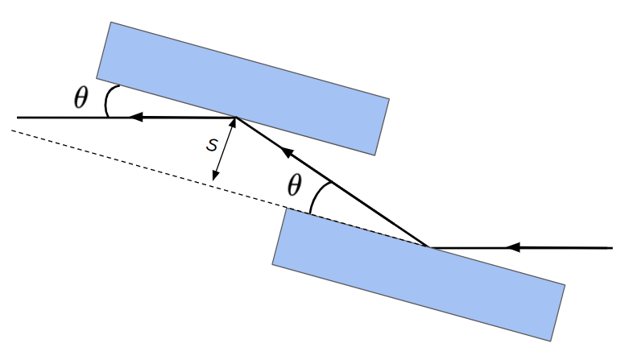

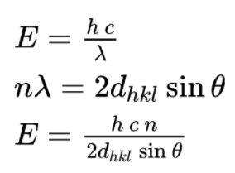

1. In a DCM, the two monochromators are always parallel, with some distance $S$ between their inner faces, as shown in the previous picture. While the first monochromator selects the desired energy based on the angle between it and the radiation beam, the second monochromator is responsible for reflecting the beam so that it exits the system in the same direction that it entered, albeit with some offset. If the diagram in the previous question is a top down view, calculate the horizontal offset of the beam when it exits the DCM.

The offset is equal to twice the distance between the inner faces of the crystals times the cosine of the incident angle, $h=2s cos(θ)$.

1. When scanning the radiation beam over an energy range, the reflection angle between the beam and the first monochromator changes, but the position of the beam as it exits the system is always in the same place (the horizontal offset in most synchrotrons never changes, regardless of the angle). However, based on your derivation in the previous problem, the offset *is dependent* on the angle. In a real synchrotron, this is avoided by having the second monochromator shift while scanning to ensure that the beam offset is constant. Below are diagrams of the monochromator in the system at four different orientations/angles relative to the radiation beam. Sketch in the position of the second monochromator for each diagram, ensuring that it is in a position where the offset will be the same in each. (Hint: You should only have to shift it along one axis)

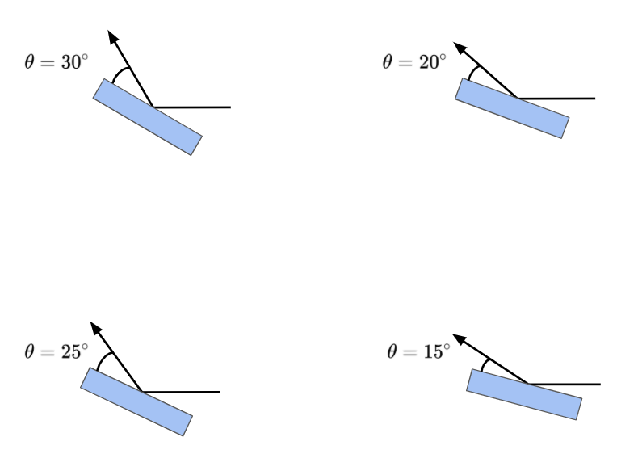

In each case the second monochromator must be shifted along the x-axis, so that the horizontal offset stays constant. If the “zero” position is the case where $θ=45°$, meaning that the second monochromator is directly above the first, then as $θ$ decreases the second monochromator must shift farther and farther to the left along the x-axis to ensure that the h of the reflected beam stays the same. This is reflected in the equation derived in the previous problem: $cos(θ)$ increases as $θ→0$, therefore $s$ must decrease to preserve $h$, which is done by shifting the second monochromator.

1. From your derivation of Bragg’s Law in part B of this section, you may have noted that the condition for constructive interference can also be satisfied by higher energy (shorter wavelength) photons. These are known as harmonics, and they can contaminate a beam with x-rays of energies other than the one we intend to select with our DCM. A common example of this is DCMs made using the Si (111) lattice plane, which have higher energy reflections from the Si (333) lattice plane. One method of removing harmonic contamination is known as “detuning”, where the second monochromator in our system is tilted at a slightly different angle than the first one. Qualitatively explain why ideally this should have a minimal effect on photons from the (111) reflection, but a more dramatic effect on photons from the (333) reflection. For more information about experimental approaches to measuring the rocking curves relevant to this question, see ref [2] and [3].

The Si (333) reflection is more sensitive to the bragg condition, as it has a more narrow Darwin width. The Darwin width is the FWHM of the reflection profile of a monochromator crystal, widely known as a rocking curve. This width is proportional to the wavelength squared, meaning that higher order harmonics (higher energy, smaller wavelength) will have a narrower Darwin width. This means that detuning exploits the (relatively) larger Darwin width of the Si (111) reflection, incurring a small reduction in the reflectivity of (111) but greatly reducing the (333) reflection.

1. Mirrors are often used to further manipulate the x-ray beam after it passes through the DCM. Similar to how one can achieve total internal reflection with appropriate conditions, X-rays can achieve total external reflection at an air-material interface. This can only occur for angles of incidence less than some critical angle, $θ<θ_{c}$, where the critical angle is approximately proportional to 1 over the energy, $θ_{c}∝$ 1/E. Explain how one could use this to create a low pass filter to screen out harmonics.

A mirror is placed along the beamline and is angled such that the incident x-rays will achieve total external reflection at energies near the energy values being scanned over. Higher energy harmonics will have a coresponsigly lower critical angle, and will not be able to achieve total external reflection, partially screening them out of the resulting x-ray beam.

1. Much of the polychromatic x-ray beam incident on the monochromator in a DCM will end up being absorbed or inelastically scattered. This deposits a large amount of energy very quickly into the monochromator, causing it to heat up. Why might this be an issue for a DCM?

Changes in temperature can cause the lattice constants of the monochromator to change. This can cause a loss in beam intensity and stability. The DCM is a precision optical tool, and in general even small changes in temperature can have dramatic effects on the quality of the x-ray beam.

Citations: [1] Bunker, Grant. *Introduction to XAFS: a Practical Guide to X-Ray Absorption Fine Structure Spectroscopy*. Cambridge University Press, 2010, [2] Masiello, Fabio, et al. “Rocking Curve Measurements Revisited.” *Journal of Applied Crystallography*, vol. 47, no. 4, 2014, pp. 1304–1314., doi:10.1107/s1600576714012527., [3] Koningsberger, D.C. *X-Ray Absorption: Principles, Applications, Techniques of EXAFS, SEXAFS and XANES*. 1988.